Sreelakshmi Nambiar

RA1911029010074

AIM-BGP Configuration in CISCO Packet Tracer

PROCEDURE-

Let us have two AS 100 and 200 each with a router for forwarding traffic from/to the AS.

In Packet Tracer, after assigning IP addresses to PCs and FastEthernet and Serial interfaces,

use # router bgp AS number command to configure the router in Global Config mode.

Next, add the neighbour router’s IP Addresses to this router using the command

#neighbor IP Address remote-as AS Number Where IP Address – IP Address of the

neighbor router and AS Number is the neighbour router’s AS Number

Then, add the network’s IP addresses. That is, the IP address of all the networks connected

with this router.

#network IP address mask subnet mask

Next step is to check the connectivity using ping command.

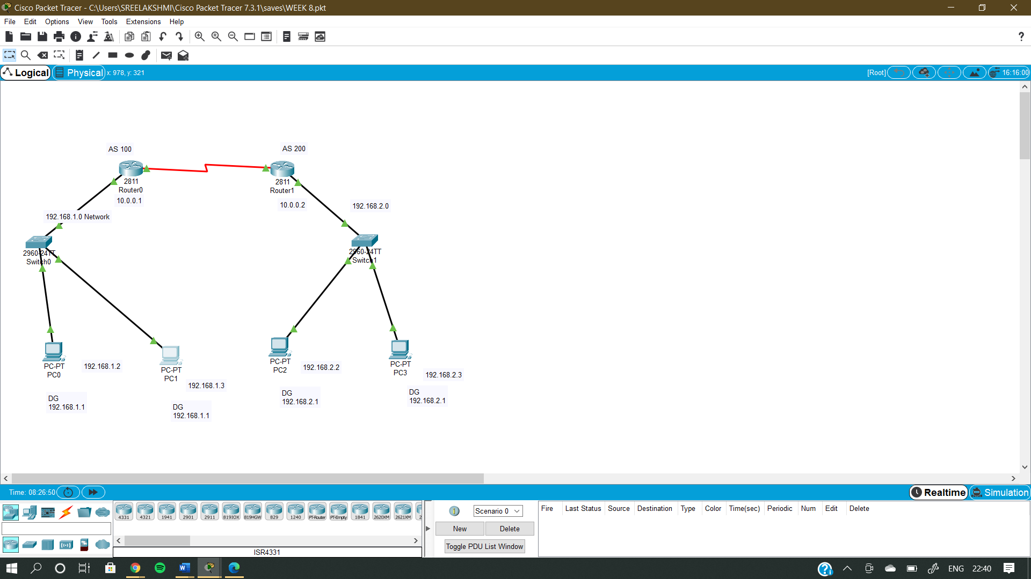

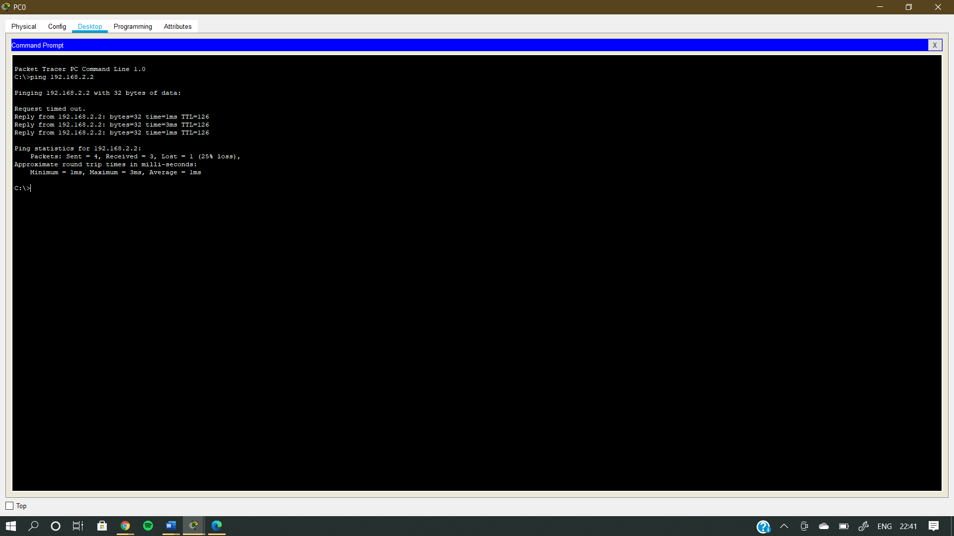

RESULT-The BGP protocol is implemented